

CITY OF KENMARE, NORTH DAKOTA

ALL – HAZARDS

EMERGENCY OPERATIONS PLAN

Contents
EMERGENCY RESPONSE PRIORITIES 3
PRE-IDENTIFIED LOCATION 3
CRITICAL EQUIPMENT……………………………………………………………………………………….4
INCIDENT ACTIONS for COMMUNITY LEADERS 5
INCIDENT ACTIONS for INCIDENT COMMANDERS 6
CONTACT NUMBERS 7
WARD COUNTY EMERGENCY MANAGEMENT OFFICE 8
PUBLIC INFORMATION OFFICER 9
EMERGENCY OPERATIONS CENTER APPROVAL LIST……………………………………………….10
APPENDIX A DIRECTING AND CONTROLLING A RESPONSE 11
APPENDIX B INCIDENT COMMAND STRUCTURE
Tornado/Severe Weather/Flood/Wildfire/Aircraft Crash/Train Derailment/Chemical Release or Spill 12
APPENDIX C INCIDENT COMMAND STRUCTURE
Bombing/Bomb Threat/Act of Terrorism/Civil Disobedience/Cyber Attack/Lost or Missing Persons 13
APPENDIX D INCIDENT COMMAND STRUCTURE
Outbreak of Contagion or Communicable Disease 14
APPENDIX E EVACUATION AND SHELTER CHECKLIST 15
APPENDIX F Functional Annexes 17
-Law Enforcement 17
-Fire Services 21
-Emergency Medical Services 24
APPENDIX G Emergency Support Functions (ESFs) 27
-ESF 1: Mid-Dakota American Red Cross 27
-ESF 2: Salvation Army Northern Division 30
-ESF 3: Amateur RADIO Emergency Service (ARES) 33
-ESF 4: North Dakota Wing Civil Air Patrol 35

Emergency Response Priorities
The City of Kenmare functions to protect the following priorities when responding to any event:

- Human life
- Public health
- Public and private property
- Environmental/subsistence resources
- Socio-economic and cultural resources

PRE-IDENTIFIED LOCATIONS
Emergency Operations Center (EOC):
- Primary EOC: Kenmare Public School
  - 300 7th Ave. NE
- Secondary EOC: Kenmare City Hall
  - 5 3rd St. NE

Shelter Location(s):
- Primary Shelter: Kenmare Public School
  - 300 7th Ave. NE
- Secondary Shelter: Kenmare Grade School
  - 623 North Central

Joint Information Center (JIC):
PIO: Kenmare City Council----Mayor, Dwight Flygare
Alt. Marki Ellis, City Auditor
The Public Information Officer will set up a small area, called the Joint Information Center, where these statements can be issued to the media. This should be away from the incident and the Emergency Operation Center.

- Primary JIC: Kenmare City Hall
  - 5 3rd St. NE
- Secondary JIC : Kenmare Fire Department
  - 617 Central Ave.

Critical Equipment
A list of all equipment at the community’s disposal that needs to be maintained or may need a backup during an emergency or disaster. Examples: generator, lift station, water pump, etc.

1 | Backup generators for water tower
0 | Need backup generators for master lift station
0 | Need backup generators for #2 lift station
0 | Need backup generators for booster station
0 | Need backup generators for master control well #1
0 | Need backup generators for master control well #2
0 | Need backup generators for master control well #3
0 | Need backup generators for fire station
0 | Need backup generators for ambulance station
0 | Need backup generators for City Hall
1 | Road maintainers
1 | Pay loader and attachments
1 | Bobcat and attachments
4 | Police department vehicles
2 | City ambulance vehicles
4 | City vehicles
1 | 4” trash pump
1 | 2” trash pump
1 | Dump truck
1 | Sanding truck
1 | 4440 tractor and loader

INCIDENT ACTIONS for community Leaders
First responders will already be dispatched to the disaster. Community leaders or their successors shall implement these actions as soon as an imminent threat to life or property is known to exist or an actual incident occurs without warning.

Call an emergency meeting of all available community leaders and officials.
Identify all known information about the situation.
Have a copy of the community’s Incident Action Plan available.
Communicate with first responders to select and identify an Incident Commander to set up the Incident Command.
Provide the Incident Commander with a copy of the community’s Incident Action Plan.
Open the Emergency Operations Center if requested by the Incident Commander.
Stay in connect with the Incident Commander for progress reports.
Any leader or official not assigned to a position by the Incident Commander, standby and wait for an assignment.
Ensure all events are recorded.
Meet as often as needed, but at least once daily.

INCIDENT ACTIONS for Incident Commanders CHECKLIST

Incident Command is established.
Notify Central Dispatch of the situation.
Notify Ward County Emergency Management of the situation.
Assign an individual to record all events.
Assign units to assess damages.
Assess critical resources.
If disaster meets the criteria, notify City leaders to open the Emergency Operations Center.
Complete all required ICS forms (located in the community’s Incident Action Plan) and ensure copies are made and sent to the Ward County Emergency Management Office. Fax 701-857-6564
Assign all requested personnel, equipment, and other resources upon arrival.
Continue to keep track and account for all personnel, equipment, and other resources.
Designate the need for a Public Information Officer.
Request and evaluate present and future forecast for damage potential.
If emergency is too large or lasts longer than 8hrs, request mutual aid the Emergency Operations Center/Emergency Manager. (Only the Incident Commander can do this)
Plan for relief of responders at the end of the operational period.
Plan for transfer of command.
Begin initial recovery actions as early as possible.
Plan for demobilization of all personnel, equipment, and other resources when they are no longer needed.
Send regular updates to the Emergency Operations Center/Emergency Manager.

CONTACT NUMBERS
For Local Responder Agencies
(Please update this list regularly)
Agencies Contact Office & Home Phone Fax

Kenmare EMS Trinity Hospital Kenmare (primary) 701-385-4296

Kenmare Fire Department Fire Chief 701-848-6473

Trinity Hospital Kenmare Administration 701-385-4296

Kenmare Police Dept. Administration 701-385-4411

City of Kenmare Mayor/Auditor 701-385-4232

Kenmare School Principal 701-385-4996 (Off)

Ward County Emergency Mgmt Director 701-857-6534 (Off) 701-857-6564
701-340-4314 (Cell)
Assistant Director 701-857-6562 (Off)
701-500-5546 (Cell)

North Dakota Highway Patrol Local Office 701-857-6937 701-857-6924

American Red Cross Minot Office 701-852-2828

BNSF Railroad Emergency Reporting Line 800-832-5452

Canadian Pacific Railroad Emergency Reporting Line 800-716-9132

Minot Central Dispatch Center PSAP Manager 701-852-0111

North Dakota Dept. of Health Emergency Preparedness & Response 701-328-2270 701-328-5270
Environmental Health Section 701-328-5150 701-328-5200

North Dakota Department of Minot District 701-857-6925 701-328-0310
Transportation

Salvation Army Northern Division Disaster Services 701-838-8925 701-838-2511

Ward County Highway Department County Engineer 701-838-2810

Ward County Water Resource Board Chairman 701-838-2810

MDU 800-638-3278
BDE 800-472-2983

WARD COUNTY EMERGENCY MANAGEMENT OFFICE

The City of Kenmare may contact the Ward County Emergency Management Office at any time for assistance. The City of Kenmare should call when one of the following occurs:

The City of Kenmare’s resources are overwhelmed.

The possibility of the City of Kenmare’s resources being overwhelmed.

An incident that lasts longer than eight hours.

Ward County Emergency Mgmt Director 701-857-6534 (Off)
701-340-4314(Cell)
701-857-6564 (Fax)

Assistant Director 701-857-6562 (Off)
701-500-5546 (Cell)
701-857-6564 (Fax)

PUBLIC INFORMATION OFFICER
The Mayor of the City of Kenmare or a designee will be identified at the Public Information Officer (PIO). The PIO will use this guide to ensure the citizens of Kenmare and Ward County know of the threat and recommended protective actions, and that the City of Kenmare is equipped with appropriate checklists and are knowledgeable of the process of the incident command system. Please see the command charts in the appendices to see where the PIO falls in the command structure.
City of Kenmare Public Information Officer
Name: Home: Cell Phone:
Primary: Dwight Flygare 701-385-4669
Alternate: Kenmare PD 701-385-4411
- Attend emergency incident action planning meetings to receive information and assignments.

- Provide people with information on what to do.

  - Copy and distribute appropriate checklists to those assigned to accomplish checklist tasks.
  - Copy and distribute daily Incident Status Summaries (ICS-209).

- If possible, conduct an inspection of areas prone to impact from the threat and document pre-incident conditions and include photographs.

- Keep citizens and visitors informed about the incident. Schedule a public/media briefing at the same time and place at least, but not limited to once a day.

  - Ensure the information you release is approved by the Incident Commander.
  - Make sure you know the truth and tell it to the public.
  - If you can't answer a question, say so and promise to provide the answer at the next public/media briefing.
  - Advise all incident command system members of the following standing operating procedure: to prevent rumors and misinformation, the Public Information Officer will be the only voice to the public from the City of Kenmare other than the Incident Commander and others needed at public/media briefings to provide technical expertise. Any responder who receives a question about the incident should refer the questioner to the Information Officer for an answer.

- Report time worked, equipment used and supplies expended on the incident to the Finance/Admin Section Chief.

Go to http://training.fema.gov/EMIWeb/IS/is702.asp to learn more about providing information to the public during a disaster.

EOC APPROVED LIST

Due to Open Meeting Laws, only 2 ELECTED officials are allowed in the EOC at one time.

Primary: Gary Kraft & Dwight Flygare

Alternate: Marki Ellis & Todd Ankenbauer
Name | Title | Agency | Phone | Email
Nate Condit | Chief | Kenmare Fire Department | 701-848-6473
Eisenbraun, Julie | EM Support Specialist | Ward County Emergency Management | 701-857-6560 | julie.eisenbraun@wardnd.com
Dwight Flygare | Mayor | City of Kenmare | 701-385-4669 | flygare@restel.net
Marki Ellis | Auditor | City of Kenmare | 701-385-4232 | cityofkenmare@restel.com
Gary Kraft | Chief | Kenmare Police Department | 701-385-4411
Schooling, Amanda | Director | Ward County Emergency Management | 701-340-4314 | amanda.schooling@wardnd.com
Weber, Kris | Assistant Director | Ward County Emergency Management | 701-857-6562 | kristina.weber@wardnd.com
Todd Ankenbauer | Alderman | City of Kenmare | 701-848-6129 | tcjmank@restel.net
Terese Schmidt | Alderman | City of Kenmare | 701-848-6024 | Terese.skjordal@gmail.com
Jamie Livingston | Alderman | City of Kenmare | 701-217-0195 | jlivingston@stbk.com
Ken Keysor | Alderman | City of Kenmare | 701-339-2513 | ken@bdec.coop
Paul Christian Standard | Alderman | City of Kenmare | 701-339-2515 | pcstandard@yahoo.com
Glen Froseth | Alderman | City of Kenmare | 701-217-0000 | gdfroseth@restel.com

APPENDIX A

DIRECTING AND CONTROLLING A RESPONSE

The City of Kenmare will initially use the Incident Command System structure identified below to direct and control a disaster emergency response. The response to incidents within the City of Kenmare will be led by an Incident Commander (IC) as indicated in the top box. The IC is responsible for all the command and general staff functions shown until people are assigned to those functional positions. Thus, one of the IC’s first actions should be the assignment of the best-qualified, available person to fill each position.

The checklists in this plan are meant to eliminate the need for an Incident Action Plan. If they don’t address everything that needs to be done, a Planning Chief may be ordered. The IC may also order other individuals to augment the Incident Command Structure, especially if incident management is likely to exceed one 12 hour operational period and continue for an extended period of time. Augmented personnel will be integrated into and work with the structured response of the City of Kenmare. To order this augmentation to the incident command structure, contact Ward County Emergency Management.

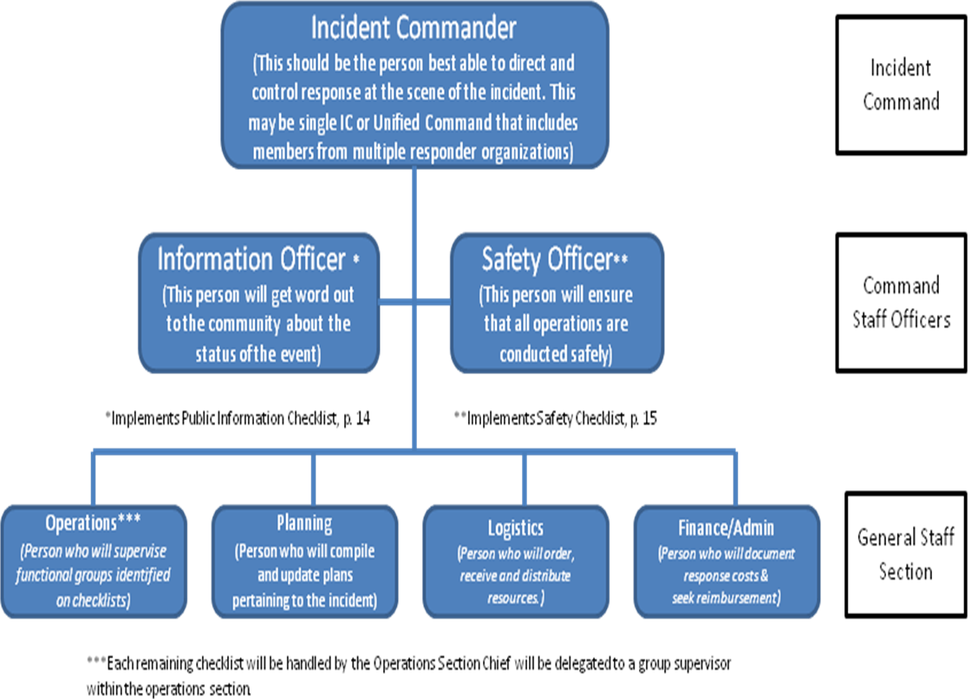

APPENDIX B

INCIDENT COMMAND STRUCTURE

Tornado/Severe Weather/Flood/Wildfire/Aircraft Crash/Train Derailment/Chemical Release or Spill

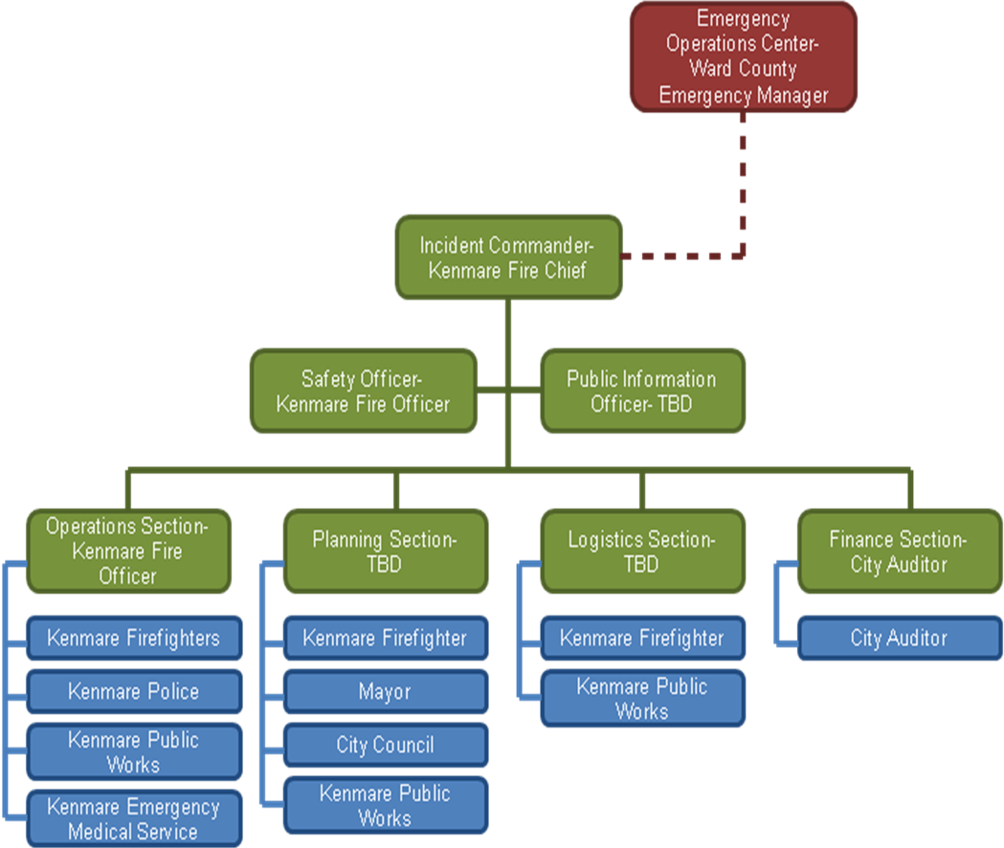

APPENDIX C

Incident Command Structure

Bombing/Bomb Threat/Act of Terrorism/Civil Disobedience/Cyber Attack/Lost or Missing Persons

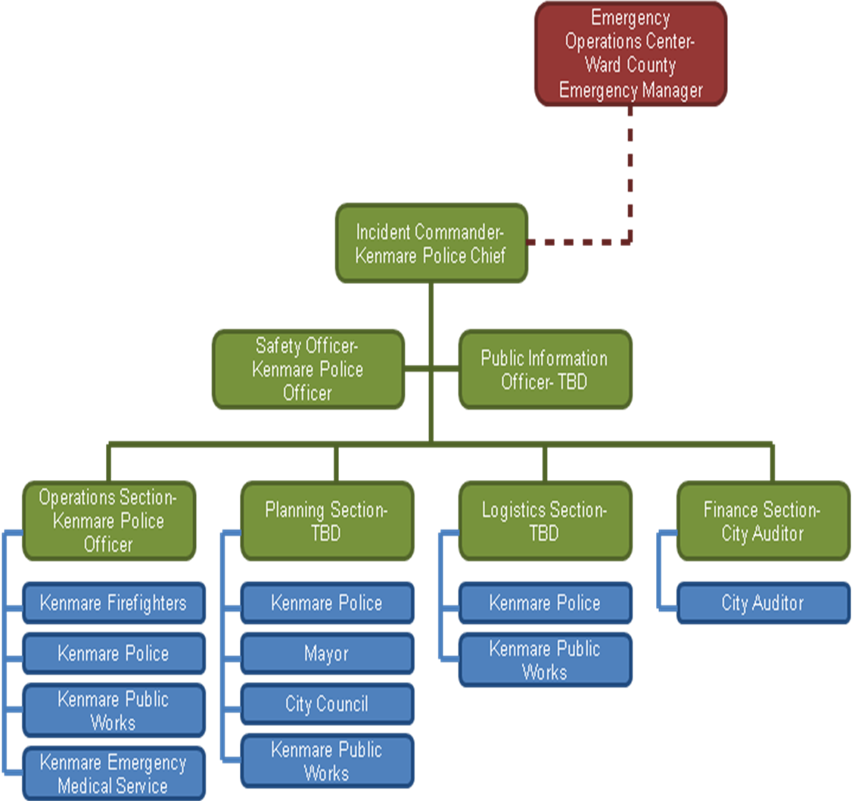

APPENDIX D

Incident Command Structure

Outbreak of Contagion or Communicable Disease

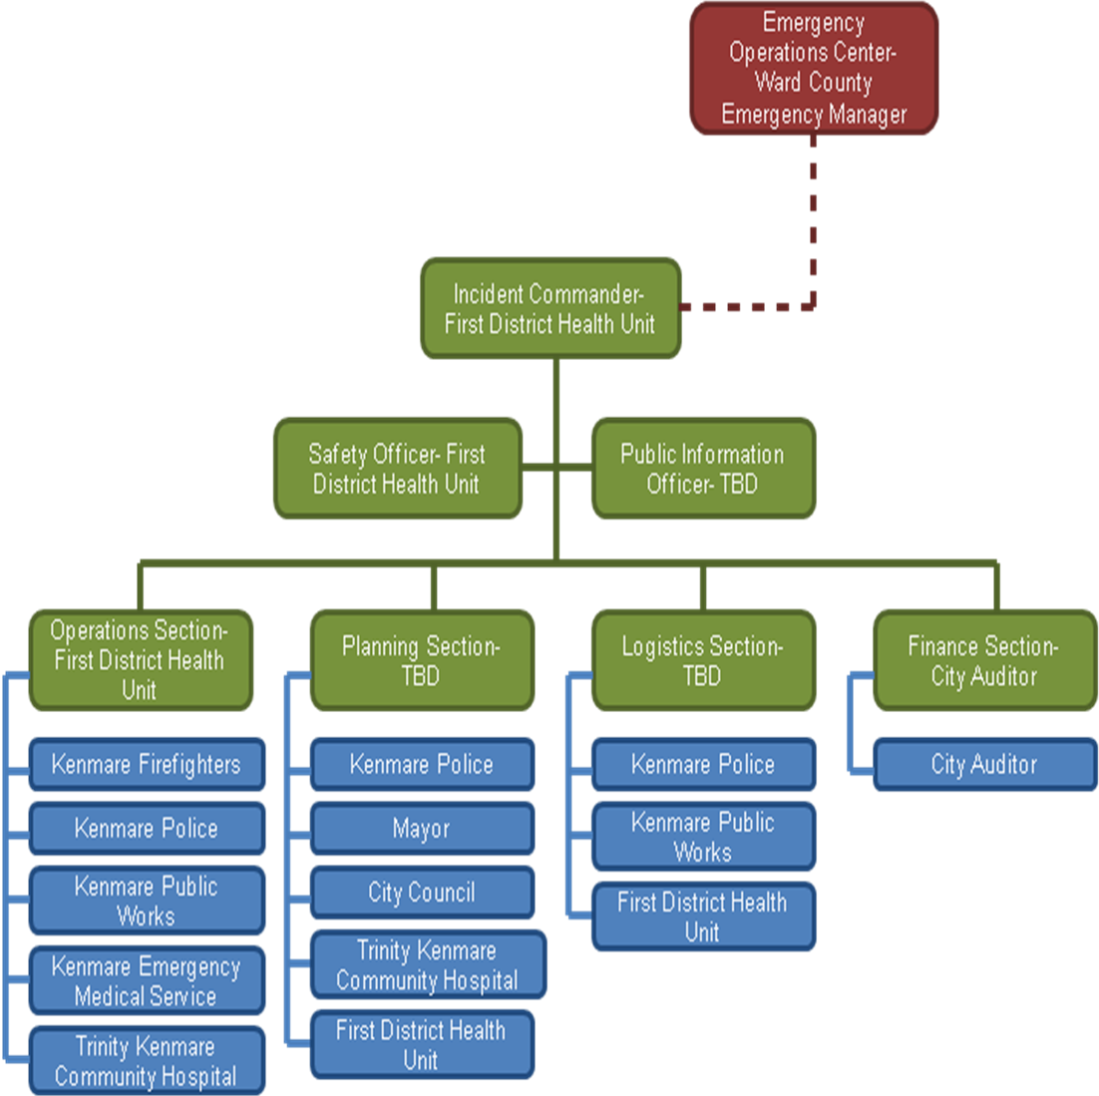

APPENDIX E

EVACUATION AND SHELTER CHECKLIST
NOTE: Evacuation of people from the City of Kenmare by air, water, or land is an emergency, lifesaving measure and shall be used only as a last resort. Not only can it be expensive, but in bad weather it can be dangerous or even impossible. Returning people to the community and resupplying emergency survival items occurs after the emergency phase of an incident. It is thus not considered an emergency, return will be by whatever means are available at the time, and we will have to share the responsibility and expense. Whenever possible, people who must leave their homes will be sheltered in a safe, pre-designated shelter facility. People cannot be forced to vacate their property during a time of emergency but when impact to a community by disaster is imminent, local officials may strongly recommend evacuation measures.

Designated Storm Shelter: Kenmare School, 300 7th Ave NE Kenmare, ND 58746

- Contact the Mid-Dakota Chapter of the American Red Cross (844) 292-7667 to obtain emergency services for individuals and families affected by disasters, including individual disasters like house fires. The Mid-Dakota Chapter of the American Red Cross and the Local chapter of the Salvation Army (701) 838-8925, provides emergency clothing, groceries, bedding and other available assistance based on individual/family needs. And, they have a system to ship these items to the City of Kenmare.

When: As soon as individual/family needs are known.
  - Prepare to shelter people whose homes are damaged. Estimate the number of evacuees, open sufficient shelters and arrange for their operation. Make preparations for the orderly movement and reception of those to be sheltered. This may need to be done more than once if additional areas become threatened.

When: As soon as the potential need for shelters is known.
  - If available evacuation routes are limited and flooding may occur but not render the routes impassable, arrange for markers to identify the route alignment, or arrange for pilot vehicles to guide evacuees. Assure that evacuation routes to the staging areas or shelters selected will not become impassable before they can be reached.

When: As soon as evacuation is considered
  - Help people move to shelter:

When: When an evacuation has been ordered by the City of Kenmare Incident Commander.

  - Monitor the status of people with special needs. They could be: physically (e.g., hearing, sight or mobility-impaired) or mentally challenged; those who don't speak English; the institutionalized; the aged or infirm; the incarcerated; the hospitalized; school children; children in day care; nursing home residents; transient populations; and people without transportation.

When: Any time evacuation or sheltering is being considered
  - Report time worked, equipment used and supplies expended on the incident to the Finance/Admin Section Chief.
When: Throughout the incident

APPENDIX F

Functional Annexes

Law Enforcement
Purpose:
This function provides procedures for preparedness, response, and recovery to provide a coordinated effort for the immediate protection of life and property.
The functional coordinator will provide direction to coordinate the actions of law enforcement through Unified Command (UC) under the Incident Command System (ICS). Responders will ensure the immediate safety of all citizens, maintain law and order, protect public and private property, provide protection for essential industries, and supplies and facilities for any type of disaster.
Coordination:
This function coordinates with the unified command as required by Incident Commander.
Supervision:
Driven by disaster type; normally this function reports to Incident Commander but may become the Incident Commander depending on disaster type. All information and reports from this function are requested and given to the Incident Commander.
Primary Function:
Traffic Control, Crowd Control, Site Security, and Evacuation
Secondary Function:
Search and Rescue and Morgue, Forcible Entry and Armed Suspect Confrontation, Bomb and Suspicious Package Response,
Situation:
- During an emergency and/or hazard, law enforcement agencies must expand their operations to provide increased protection. Within Ward County, law enforcement agencies such as Minot Police Department, Ward County Sheriff’s Department, Highway Patrol, and all other city police departments, are available upon utilization of Memorandums of Understanding (MOUs).
- The Minot Police Department and Ward County Sheriff’s Office have a joint Special Weapons and Tactics (SWAT) team to respond to any incidents within Ward County which may include high-risk operations that may involve confronting heavily-armed criminals, forcible entry and hostage rescue, and performing high risk arrests.
- The Ward County Sheriff’s Office and the Minot Police Department have coordinated for the provision of a joint Bomb Squad with personnel which have acquired specialized training to respond to any incident to seek out and disable or render safe explosives and incendiary devices.
- The Ward County Sheriff’s Office and the Minot Police Department have established a Hostage Negotiations Team (HNT) to handle negotiations with individuals whom are barricaded or present a clear and immediate danger to themselves and others.
- The Minot Police Department utilizes Police Service Dog (K-9) units as a resource to assist response to incidents involving crowd control and civil disobedience and to support search and rescue in Minot and throughout Ward County.
- Law Enforcement is faced with hazards with limited equipment and personnel in rural areas of Ward County.
- Law enforcement agencies will be called up for operations during times of an emergency and/or hazard occurs.
- Law enforcement agencies will be required to expand to continue their efforts to protect lives and property during emergency situations.
- During large-scale emergencies and major disasters, law enforcement agencies may be required to expand their operations and undertake certain tasks that are not performed on a day-to-day basis.
- Large-scale emergencies and acts of terrorism may adversely impact law enforcement personnel, equipment, and facilities.
Assumptions:
- City of Kenmare Police Department’s duty is to protect the lives and property of all residents within Kenmare.
- Police are prepared and equipped to provide: traffic control when an emergency has disabled automated systems; scene security, established in the form of one or more perimeters around the location of an emergency and/or incident; general security, accomplished by various means of patrol, including air, vehicle and/or foot; and crowd control when situation has caused convergence of disorderly persons.
- When responding to any incident, all law enforcement personnel will follow their established Standard Operating Procedures.
- City of Kenmare Police Department’s capabilities can be overpowered by any large scale emergency and/or hazard that could require other counties and/or state assistance.
Lead Agency:
City of Kenmare Police Department

Support Agencies:
State Highway Patrol, North Dakota Bureau of Criminal Investigation (ND BCI), Minot Police Department Special Weapons and Tactics team (SWAT), Minot Police Department Hostage Negotiation Team (HNT), Minot Police Department Bomb Squad, Minot Police Service Dog (K-9) units, and other volunteer agencies
Preparedness:
- Identify critical infrastructure and essential facilities that need enhanced security during emergencies and/or disasters and is the lead agency on evacuation planning and procedures, working closely with other agencies to assure the timely initiation of an evacuation.
- Assures Mutual-Aid Agreements exist to provide law enforcement activities for the incident at hand as well as continuity of service for the unaffected areas of the county and/or community.
- Reviews operating guidelines and assures all vehicles and equipment are in a state of operational readiness.
- Assures procedures for the apprehension, incarceration, and transportation of criminals are in place and operational.
- Assure appropriate staff is trained in the primary and supportive roles to assure effective and efficient operations during emergencies. In addition, other agencies will be provided training when supporting law enforcement operations to assure safety.
- Review policies for animal control.
- Coordinate activities with emergency manager if necessary.
- Prepare for possible shortage of water, electricity, chemicals, and fuel.
- Complete daily assessments on special events, weather reports, road closures, fire danger, or other factors that may influence operations.
- Coordinate communications requirements with Public Safety Answering Point (PSAP)
- Coordinate with the Emergency Manager, Red Cross, and Social Services to determine locations of specials needs groups (handicapped, elderly, and transients) that may need special consideration.
- Coordinate security procedures with public health function in the event of a mass casualty incident.
- Develop procedures to implement crowd and traffic control procedures to maintain perimeters and civil order throughout the county and/or community during emergencies
- Gather intelligence and share appropriate information to other emergency response agencies as necessary.
- Assure all personnel are adequately trained, competent, and able to utilize the Incident Command System.

Response:
- Isolate and secure the scene, establish control zones.
- Establish on-site command post and communication.
- Evaluate scene safety and security, as well as, establish outer perimeters to protect the public and emergency response personnel as well as allow other emergency response agencies access to the scene, access to the affected property and access to fire hydrants. Perimeters shall also include ingress and egress routes for all emergency response equipment and vehicles as well as ingress and egress screening of vehicles and personnel.
- Assist warning function(s).
- Activate Mutual Aid Agreements, as needed.
- Utilize self-protective measures (proper Personnel Protective Equipment (PPE) if available, minimize number of personnel exposed, time, distance & shielding).
- Initiate public safety measures (evacuation or shelter-in-place, if necessary).
- Coordinate with fire services if evacuation is required.
- Assist in the coordination and security of evacuation points for special needs groups with special transportation requirements and, if needed, assist in transportation in large scale evacuation operations.
- Assign personnel to traffic control points in the event of an evacuation.
- Assign security personnel to shelters, as needed.
- Assist with perimeter control, scene safety and security, and isolation or restraint of patients.
- Provide security to affected areas, as needed.
- Coordinate search and rescue support resources.
- Coordinate traffic and crowd control areas.
- Provide damage reports to EOC.
- Advise on road closures and parking restrictions.
- Maintain status or record of manpower, vehicles and equipment.
Recovery:
- In the event of an evacuation, establish traffic control for return of population, resources, and assist with special needs groups, if required.
- Return all equipment rented or borrowed by each respective law enforcement agency and replenish or replace inventories as necessary; maintenance and repairs to all law enforcement vehicles and equipment shall also be conducted.
- Participate in damage assessment.
- Review and analyze law enforcement operations and update plan with any changes in procedures.

Fire Services
Purpose:
This function provides procedures for preparedness, response, and recovery to provide a coordinated effort for the immediate protection of life, property, and incident stability.
The incident commander will provide direction to coordinate the actions of fire departments, search and rescue units, and hazardous materials response teams. Through unified command under the Incident Command System (ICS) responders will coordinate to ensure the immediate safety of themselves, all citizens, protect public and private property, provide for incident stabilization, conduct Hazardous Materials assessment and mitigation, and provide protection for essential industries, supplies, facilities, and infrastructure for any type of disaster.
Coordination:
This function coordinates with unified command as required by Incident Commander.
Supervision:
Driven by disaster type; normally this function reports to the Incident Commander but may become the Incident Commander depending on disaster type. All information and reports from this function are requested and given to the Incident Commander.
Primary Function: Fire Protection, Fire Suppression, Search and Rescue, EMS Control, Hazardous Materials, and Technical and Water Rescue.
Secondary Function:
Evacuation, Traffic Control, Sheltering, and Site Security
Situation:
- The City of Kenmare possesses a critical emergency asset in its volunteer fire department.
- All volunteer firefighters participate in training and certification prior to any response as well as regularly scheduled training to maintain certification.
- All fire Departments who service predominantly rural areas throughout the county must provide a quick and effective response with limited equipment and personnel.
- The Kenmare Fire Department may have limited access to utilities or natural resources to suppress wild fires, terrorism attacks, hazardous materials incidents, and chemical, biological, radiological, nuclear and explosive emergencies.
- Specialized teams such as HAZMAT, Search and Rescue, Technical and Water rescue, and many of the countywide fire departments may, through mutual aid agreements and memorandums of understanding, respond to assist functions including fire suppression and rescue in a time of emergency within the City of Kenmare.
Assumptions:
- In most situations Fire Department personnel, equipment, resources, and Mutual Aid Agreements (MAA) with private/public organizations should be adequate to augment response to any emergency or disaster.
- The City of Kenmare will utilize the Incident Command System (ICS) to manage emergency operations at any incident.
- All coordination of departments, resources, personnel, and communications will take place by using the Incident Command System.
- If all resources, personnel, and equipment have been used up, the Emergency Manager will contact the state to obtain resources, personnel, and equipment through NDDES.
Primary Agency:
Kenmare Fire Department
Support Agencies:
Minot Hazmat Team, Search and Rescue, Technical and Water rescue, Fire Departments throughout Ward County, and other volunteer agencies
Preparedness:
- Determine available resources and review and update Mutual Aid Agreements and Memorandums of Understanding to augment response capabilities.
- Review fire Standard Operating Procedures (SOP’s).
- Provide training for volunteer firefighters and refresher training in traffic control procedures.
- Develop plans for utilizing volunteers.
- Accomplish inspections of commercial buildings and shelter/emergency lodging facilities for adherence to fire safety codes and ordinances.
- Response capabilities are assured through routine, scheduled checks and maintenance to all standby generators and Self Contained Breathing Apparatus (SCBA) cascade compressor systems. In addition, inventories of necessary items are maintained.
- Procedures and operating principles are coordinated with local health and EMS providers to assure efficiency and effectiveness at incidents involving emergency medical triage, treatment and transport.
- Staff and volunteers are kept updated on all changes to operating guidelines.
- Procedures are reviewed and refresher training given for decontamination procedures.
- Prepare for possible shortage of water, electricity, chemicals, and fuel.
- Coordinate activities with Ward County Emergency Management.
- Coordinate communications requirements with communication officer.

Response:
- During response, the Fire Department implements the National Incident Management System (NIMS) and establishes a command location and/or command post, which may include a vehicle or designated area outfitted with room to work and communication capabilities.
- Fire Departments are responsible for assuring scene safety and to establish control and safe zones.
- Determination of personnel and equipment needed is made and requests are made accordingly through mutual-aid. Damage assessments are made and collected that are forwarded to the EOC.
- Initiate public safety measures such as rescue, evacuation, or shelter-in-place.
- During chemical and WMD chemical incidents water supplies are established and decontamination is implemented.
- Coordinate with utility companies for the termination of utilities during an incident and coordinate with respective oil companies for spills and pipeline emergencies.
- Perform in search and rescue operations for lost, injured or trapped victims and conduct or assist in extrication activities.
- Coordinate Fire Departments role in providing emergency medical stabilization and establish triage and treatment.
- Coordinate inspection and damage assessment of affected buildings for safety and stability, as soon as possible after event.
Recovery:
- Return borrowed equipment and acknowledge assistance.
- Replenish depleted supplies.
- Contact utility companies if homes and/or businesses are damaged by flood waters if needed.
- Complete all required reports.
- Maintenance and repairs to all apparatus and equipment shall be conducted to comply with NFPA guidelines..

Emergency Medical Services
Purpose:
Kenmare Emergency Medical Services provides ongoing facilitated life support measures to the communities within their jurisdictions throughout the disaster periods of preparedness, response, and recovery.
Coordination:
This function coordinates with the unified command as required by Incident Commander.
Supervision:
Driven by disaster type; normally this function reports to the Incident Commander but may become the Incident Commander depending on disaster type. All information and reports from this function are requested and given to the Incident Commander.
Primary Function:
Provide ongoing advanced life support and emergency medical care during an emergency which consists of medical command, triage, treatment, and transportation of civilian and emergency services personnel, consistent with established EMS protocols.
Situation:
- EMS personnel, resources, and services will address everyone within the Kenmare Ambulance response district which includes: senior citizens, people with disabilities, people with special medical and/or dietary needs, people with limited socio-economic resources, people who are non-English speaking, pregnant woman, children, as well as infants.
- Local EMS, Trinity, and the First District Health Unit have first-line responsibility for response to health-related emergencies.
- Local EMS, Trinity, and First District Health Unit are responsible to dispense and/or vaccinate Ward County if needed.
- The First District Health Unit and/or Trinity Hospital will provide general information to the public health officials about the health status of the populations of the City of Kenmare and Ward County (i.e. disease reporting, syndromes surveillance, and specimen submission).
- Disasters and/or hazards that occur within the City of Kenmare can impact the community’s health that which in turn will require a response. Commonly affected services could include, but not limited to: waste water, solid waste, portable water, air quality, health supplies, and public health services.
- Secondary disasters and/or hazards could releaser chemical, biological, and/or radiological materials that could further impact the City of Kenmare and overpower personnel and resources.
Assumptions:
- The First District Health Unit will notify North Dakota Department of Health of the situation and status of the City of Kenmare, and further, Ward County’s need for assistance.
- Disaster and/or hazards could cause emergency services inoperable.
- Secondary disasters and/or hazards could occur that may cause health emergencies that may not have occurred in the initial disaster and/or hazard.
- An increase of injury or disease could be caused when a disaster/hazard occurs that causes a disruption of sanitation services, loss of power, and mass of people arriving in shelters all at once.
- Due to the extreme damage and devastation the hospital may need to relocate some or all of their facilities.
- A disaster and/or hazard may exceed the personnel and resources within Kenmare and Ward County which would require state and possible federal emergency resources
- Requests for support will be coordinated through the Emergency Manager or his/her designee.
Lead Agencies:
Kenmare Emergency Medical Service, Trinity, First District Health Unit
Support Agencies:
Local Fire Department, Rural Fire Department, Search and Rescue, law enforcement, and other voluntary agencies
Preparedness:
- Determine, enhance and assure local capabilities exist to:
  - Provide patient support.
  - Accommodate patient transportation needs.
  - Alternate patient care facilities (nursing homes, clinics, etc.) for various influx of patient numbers (i.e. 25 patients, 50 patients, 100 patients, 200 patients, etc.)
  - Develop mutual aid agreements with other ambulance services.
  - Determine number of patients hospitals in surrounding areas could receive and assure transport capabilities exist when necessary.
  - Coordinate with EMS/rescue squads to support an evacuation of local hospitals or nursing homes.
  - Coordinate availability of non-medical facilities useable for emergency medical care (i.e. schools, churches, MSU Dome, etc.).
  - Develop procedures to provide medical assistance at shelters.
- Enhance training in areas of weapons of mass destruction and hazardous materials; utilize NIMS Incident Command System, and participate in disaster exercises.
- Participate in response route planning for alternate routes during poor weather conditions or obstructed routes.
Response:
- Respond to the Incident Command Post, make contact with the Fire Department, the Incident Commander (IC) and establish a medical branch.
- Implement medical command, triage, treatment and transportation of the injured.
- Maintain communication with local health care providers and the IC.
- Coordinate medical resource requirements with the IC.
- Coordinate activities and resource requirements with the IC.
- Participate in morgue operations as necessary.
- Maintain records of medical operations.
- Maintain inventory and determine the needs of the victims, relaying this information to the IC for logistical support.
- Provide medical care to emergency response personnel in a location other than patient triage, treatment, and transportation locations.
- May perform or assist in search and rescue operations for lost, injured or trapped victims.
- Receive, shelter, triage, treat, and transport post decontamination victims.
- For mass casualty incidents, calls for amount and severity of victims will be made to medical control. Medical Control will in turn make decisions on the transportation mode and destination.
Recovery:
- During recovery all ambulance services and all other departments shall return all rented or borrowed equipment and replenish or replace inventories as necessary.
- Maintain and repair all vehicles and equipment.
- Make recommendation to the IC during post incident analysis’ to improve upon the emergency operation plan.

APPENDIX G

Emergency Support Functions (ESFs)

ESF 1: Mid-Dakota American Red Cross

(844) 292-7667
Purpose:
Red Cross disaster relief focuses on meeting people's immediate emergency disaster-caused needs. When a disaster threatens or strikes; the Red Cross provides shelter, food, health, and mental health services to address basic human needs. In addition to these services, the core of Red Cross disaster relief is the assistance given to individuals and families affected by disaster to enable them to resume their normal daily activities independently.
The Red Cross also feeds emergency workers, handles inquiries from concerned family members outside the disaster area, provides blood and blood products to disaster victims, and helps those affected by disaster to access other available resources.
Primary Function:
The Mid-Dakota American Red Cross provides emergency services to evacuees, disaster victims, and emergency workers involved in or threatened by a disaster. A local team of 4 staff members and 249 trained volunteers comprise the response team 24 hours a day, 7 days a week.
Preparedness:
The Mid-Dakota American Red Cross prepares for disaster response by providing up-to-date required training for all staff and volunteers who become part of the Disaster Action Team (DAT). The local DAT is part of a statewide and national network of trained and certified disaster responders. The local DAT participates in community disaster exercises with partner agencies. The DAT follows nationally established disaster response policies and procedures.
- Identify facilities suitable for:
  - Shelters
  - First Aid Stations
  - Service Delivery Sites
  - Volunteer Management
  - Staging areas to serve as collection or dissemination points (e.g. special populations requiring transportation assistance)

- Develop agreement with facilities identified for Red Cross use.
- Prepare American Red Cross Shelter Notification information.
- Recruit and train personnel to effectively manage the Red Cross response and assist citizens affected by disaster.
- Develop and implement agreements, such as Memorandums of Understanding (MOUs), with local businesses, service organizations, a and response agencies to supply goods and services required for Red Cross response during disasters.
- Assign and train a representative to act as part of the assessment team to determine needs of citizens at time of disaster.
- Identify special planning considerations for special needs populations.
- Prepare a registration and contact plan for citizens to enlist in American Red Cross services when available.
Recovery:
The Mid-Dakota Red Cross Chapter DAT can be accessed by calling the Chapter office, the local emergency manager, E911, the local EOC if activated, or law enforcement. A staff member is on duty during normal working hours and can respond within minutes to a disaster/emergency. The local “on-call” volunteer DAT can also respond to a disaster/emergency within minutes after contact from the answering service.
- Provide emergency assistance to victims and/or first responders. This may include:
  - Fixed or mobile feeding stations
  - Mass or individual shelter
  - Clothing
  - Cleaning supplies
  - Comfort kits, first aid, or supplementary medical care
  - Disaster health services
  - Establish and operate a Family Assistance Center (FAC) coordinate with Emergency Management
  - Disaster Mental Health (MDH) services
- As soon as families are able to resume living as families rather than in shelters, they may receive additional assistances, which may include:
- Rent, bedding/linens, health needs, and minor repairs
- Additional recovery assistance may be provided via referrals with partner agencies for emotional or financial support
- All partner agencies provide assistance via MOUs with the Mid-Dakota Chapter of American Red Cross

- Other response activities include:
  - Conduct situation/American Red Cross damage assessment. Provide the situation/damage assessment information to emergency management or the EOC, if activated.
  - Liaison with government agencies and other organizations providing human services.
  - Coordinate with emergency management office(s) and EOC(s) if activated. Provide an ARC representative to the EOC, if activated.
  - Maintain logs to support documentation, expenditures, situation status, resource allocations, and reports of Red Cross response.
  - Conduct periodic briefings for the personnel and participate in EOC briefings as required or requested.
  - Inform field units of all locations of shelters, aid facilities, other pertinent facilities, and provide updates to relief personnel as they come on duty.
  - Keep log of activities and update incoming shifts.
  - Coordinate with members of the clergy for emergency sheltering and counseling.
Recovery:
- Provide temporary housing for persons in shelters.
- May provide services and support to the operations and personnel in the Family Assistance Center (FAC).
- Provide disaster mental health support to those affected by a disaster.

ESF 2: Salvation Army Northern Division

(701) 838-8925
Purpose:
Salvation Army Northern Division disaster relief operations focus on meeting the public’s immediate and prolonged emergency disaster-caused needs without discrimination. When a disaster’s impact affects a community, the Salvation Army facilitates aid to supplement shelter needs and provide food, clothing and essential services to address basic human needs. The Salvation Army operations center around six main services: basic needs, counseling, disaster relief, housing, rehabilitation, and youth services. These operations seek to restore the quality of life to those residents in crisis affected by disaster.
The Salvation Army operations also support the provision of food for emergency workers, handling, sorting, and distributing donations by members of the community and abroad, and by helping those disaster-affected residents to access other available resources.
Primary Function:
The Salvation Army Northern Division provides emergency services to evacuees, disaster victims, and emergency workers involved in or threatened by a disaster. To facilitate their mission in the county of Ward, the Salvation Army has a worship and service facility at 315 Western Ave. and a thrift store at 1933 South Broadway in Minot. These centers provide food for the hungry, shelter for the homeless, counseling for the emotionally lost and other services.
Preparedness:
The Salvation Army Northern Division prepares for disaster response by providing up-to-date required training for all staff and volunteers year-round. The Salvation Army also coordinates and collaborates with other disaster relief organizations to maximize the effectiveness and efficiency of relief services. They also work closely with the Department of Homeland Security, local emergency management, and the Federal Emergency Management Agency, as well as being a member of the Souris River Basin chapter of the Volunteer Organizations Active in Disasters. The Salvation Army follows nationally established disaster response policies and procedures.
- Identify facilities suitable for:
  - Service Delivery Sites
  - Volunteer Management
  - Staging areas to serve as collection or dissemination points (e.g. special populations requiring transportation assistance)
- Recruit and train personnel to effectively manage the Salvation Army response to assist citizens affected by disaster.
- Develop and implement agreements, such as Memorandums of Understanding (MOUs), with local businesses, service organizations, and response agencies to supply goods and services required for Salvation Army response during disasters.
- Identify special planning considerations for special needs populations.
- Prepare a registration and contact plan for citizens to enlist in Salvation Army services when available.
Response:
The Salvation Army Northern Division can be accessed by calling The Salvation Army Minot Worship and Service Center, the local emergency manager, E911, the local EOC if activated, or law enforcement. A staff member is on duty during normal working hours and can respond within minutes to a disaster/emergency. The local “on-call” staff can also respond to a disaster/emergency within minutes after contact from the answering service.
- Provide emergency assistance to victims and/or first responders. This may include:
  - Fixed or mobile feeding stations
  - Clothing
  - Cleaning supplies
  - Comfort kits, first aid, or supplementary medical care
  - Disaster health services
  - Establish and operate a Family Assistance Center (FAC) coordinate with Emergency Management
  - Disaster Mental Health (MDH) services
- As soon as families are able to resume living as families rather than in shelters, they may receive additional assistances, which may include:
- Rent, bedding/linens, health needs, and minor repairs
- Additional recovery assistance may be provided via referrals with partner agencies for emotional or financial support
- All partner agencies provide assistance via MOUs with the Salvation Army Northern Division.
- Other response activities include:
  - Liaison with government agencies and other organizations providing human services.
  - Coordinate with emergency management office(s) and EOC(s) if activated. Provide an Salvation Army representative to the EOC, if activated.
  - Maintain logs to support documentation, expenditures, situation status, resource allocations, and reports of Salvation Army response.
  - Conduct periodic briefings for the personnel and participate in EOC briefings as required or requested.
  - Inform field units of all locations of shelters, other pertinent facilities, and provide updates to relief personnel as they come on duty.
  - Keep log of activities and update incoming shifts.
  - Coordinate with members of the clergy for emergency sheltering and counseling.
Recovery:
- Provide temporary housing for persons in shelters.
- May provide services and support to the operations and personnel at designated locations.
- Provide disaster mental health support and counseling to those affected by a disaster.

ESF 3: AMATEUR RADIO Emergency Service (ARES)
Purpose:
The Amateur Radio Emergency Service (ARES) is a public service provided by a reserve (volunteer) communications group within that function within times of extraordinary need. During periods of ARES activation, certified unpaid personnel are called upon to perform many tasks to augment communications for the entities within Ward County. The exact nature of every activation will be different.
Coordination:
ARES coordinates with the unified command as required by Incident Commander.
Primary Function:
ARES operations involve emergency message handling on Amateur Radio Service frequencies. These operations involve transmitting messages between critical locations such as hospitals, emergency services, emergency shelters, and the emergency operation center. These communications are handled in any mode available, with 2 meters FM being the most prevalent.
Secondary Functions:
ARES provides a pool of emergency communications personnel that can be called upon in time of need.
Preparedness:
The Amateur Radio Emergency Service prepares for disaster response by providing required training for all voluntary personnel. They also work closely with the North Dakota Department of Emergency Services and Ward County Emergency Management to prepare for operations during a disaster. ARES follows nationally established disaster response policies and procedures.
- Amateur Radio Emergency Service is comprised of experts who utilize these radios regularly. Operators are required to pass the Federal Communications Commission’s (FCC) exam to acquire an Amateur Radio License.
- Equipment is tested and maintained on a regular basis and is owned individually by the radio operators.
- Equipment is repaired by qualified and capable personnel or the manufacturer to ensure that the repairs are accurate and radio equipment is functionally ready for use.
- Trained personnel will conduct communication drills in keeping with the FCC’s requirements to test capabilities and prepare for future events.

Response:
The Amateur Radio Emergency Service is can be called up at the request of the incident commander, the local emergency manager, the local EOC if activated, or law enforcement. The local “on-call” staff is ready respond to a disaster/emergency within a half-hour to a hour after being notified.
- ARES can respond with a mobile radio facility, a radio tower, antennae, and numerous radios.
- Radio transmissions can be made locally, nationwide, or worldwide.
- If phone services are rendered unusable this means of communication via radio is ideal and can be implemented from any location to allow communications between critical facilities or areas.
- ARES is more a reactive than proactive organization as it can adapt to be implemented in any situation. As a reactive organization, most of the activities occur at the time they are requested.
Recovery:
As phone lines, cell phone towers, and other means of communication come back online, ARES may scale back its operations.

ESF 4: North Dakota Wing Civil Air Patrol
Purpose:
Civil Air Patrol provides support during emergencies and disasters in all activities associated with Search and Rescue (SAR), aerial reconnaissance, and disaster mapping. In this way, Civil Air Patrol can supplement an incident by giving a more full perspective and more quickly locating the event and determining the severity and extent.
Coordination:
Civil Air Patrol coordinates with the unified command as required by Incident Commander.
Primary Function:
Urban and Wildland Search and Rescue
Secondary Functions:
Aerial Reconnaissance, Disaster Mapping, Thermal Imaging
Preparedness:
The North Dakota Wing Civil Air Patrol prepares for disaster response by providing required training for all volunteers. The Civil Air Patrol also coordinates and collaborates with other response organizations to maximize the effectiveness and efficiency of operations. They also work closely with the Department of Homeland Security and local emergency management. The North Dakota Wing Civil Air Patrol follows nationally established disaster response policies and procedures.
- Train personnel on a regular basis in rescue skills and procedures .
- Equipment is tested and maintained on a regular basis.
- Equipment is repaired by qualified and capable personnel or the manufacturer to ensure that the repairs are accurate.
- Trained personnel will conduct aerial reconnaissance operations.
- Civil Air Patrol personnel are equipped to provide pictures, video, and thermal imaging in a time of emergency or disaster.
Response:
The North Dakota Wing Civil Air Patrol flight missions can be requested by the incident commander, the local emergency manager, the local EOC if activated, or law enforcement. The local “on-call” staff can also are ready respond to a disaster/emergency within a short time after being notified.
- Initiation of SAR missions as necessary for both general and focused areas.
- Provide a representative for the EOC if needed.
- Establish proper communications between different organizations and/or agencies if needed.
In response, Civil Air Patrol can participate and aid in the following areas:
- A disaster or chemical release has affected an undetermined expanse of land.
- Blizzards or other inclement conditions may leave motorists stranded and disoriented.
- Weather conditions such as high winds, cold temperatures, and rain could pose additional hazards to the victims and the rescue personnel.
- If a disaster and/or hazard is of large-scale, search and rescue personnel, equipment, facilities, and communications may be affected .
- During the winter months rescue personnel may have operations that include below freezing water and ice rescues.
- Extreme temperature and large expanse of search area may render search operations tedious and time consuming. Having the ability to cover more land from a different perspective and with thermal imaging equipment can increase the timeliness and allow ground search and rescue crews to find.
- During winter, aerial reconnaissance may indicate breaks in power lines that may otherwise be hard to find.
- Aerial reconnaissance also is helpful in determining the location of lost or missing persons and downed aircraft.
Recovery:
- In disaster relief, imaging such as still shots and video may provide perspective to emergency managers and public officials on where to focus relief efforts and the current state of recovery overall.

.

